Name: Period:
PhET Forces and Motion
Google: PhET Forces Motion html5 Click the first link
Part 1: Choose “Net Force”
- Check boxes that say “Sum of Forces” and “Values”
- Drag some blue guys and some red guys on the rope. Notice how the Sum of Forces changes.
- Draw 4 different pictures below showing the guys on the rope and give the left force, the right force, and the sum of forces for each picture. Hit GO and describe what happens to the cart.
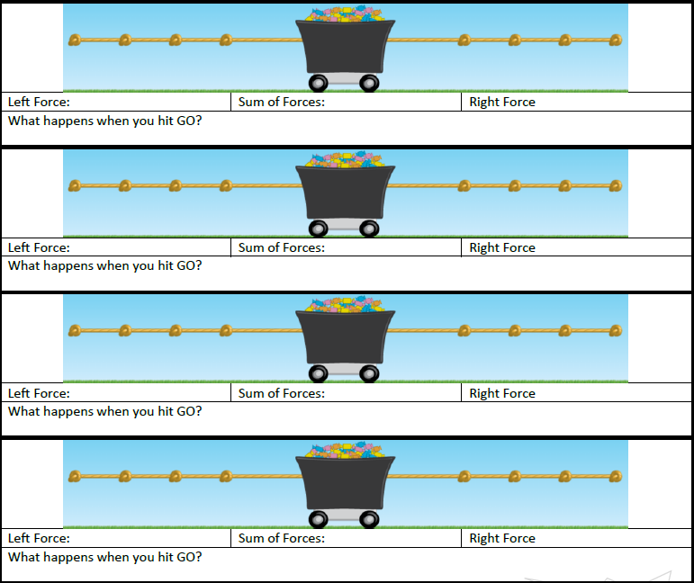 | Left force:  Right force:  Sum of forces:  What happens when you hit go?
Left force:
Right force:
Sum of forces:
What happens when you hit go?

Left force:
Right force:
Sum of forces:
What happens when you hit go?

Left force:
Right force:
Sum of forces:
What happens when you hit go?

Part 2: Choose Motion
- Check all the boxes
- Move the applied force sliders
- Change the masses
How does the mass affect the speed? For 4 different masses record the top speed.
Mass | Speed | With a larger mass, was it easier or harder to get to top speed?  Was the top speed slower or faster with a larger mass?  Did it take longer or shorter to get to top speed?
How can you find out what the mystery mass is (the present)? Write down your steps to follow on how to find the mass:

What is the mass of the mystery mass? Show your work here:

Part 3: Choose “Friction”
- Check all the boxes
- Select “Lots” of friction
What happens when you apply a 500 N force to the following masses?
Mass (kg) | Sum Force (N) | Top Speed | What happens when you reach top speed and stop pushing?

What is the mass of the mystery mass in kg?

Some masses would not move with a 500 N force. Which ones and why?

What variable could you change to get the masses in the last question to move? Does it work?

Part 4: Choose “Acceleration”
- Check all the boxes

Move friction slider to “None” Apply a force to a mass to get it moving until the speed is at 5 large tick marks. Can you get the mass to be completely at rest again? How and why or why not?

Change the mass so that its significantly different than the last question. Repeat the steps. Can you get this mass to be stationary? Was it easier or harder than in the last question?

How are mass and acceleration related? (If you change one, what happens to the other one?)

How are force and mass related? (If you change one, what happens to the other one?)

